TASK 3

**Step 1. Create a VPC**

1. Go to VPC Dashboard → Your VPCs → Create VPC
2. Name: Project-VPC
3. IPv4 CIDR block: 10.0.0.0/16
4. Enable DNS hostnames
5. Click Create VPC

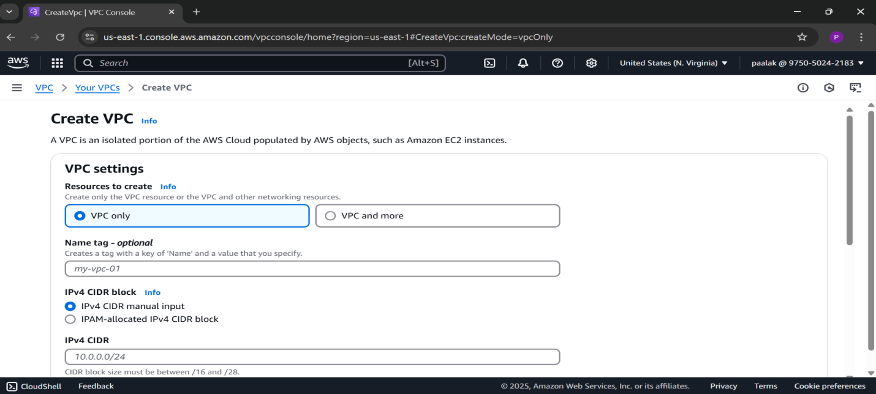

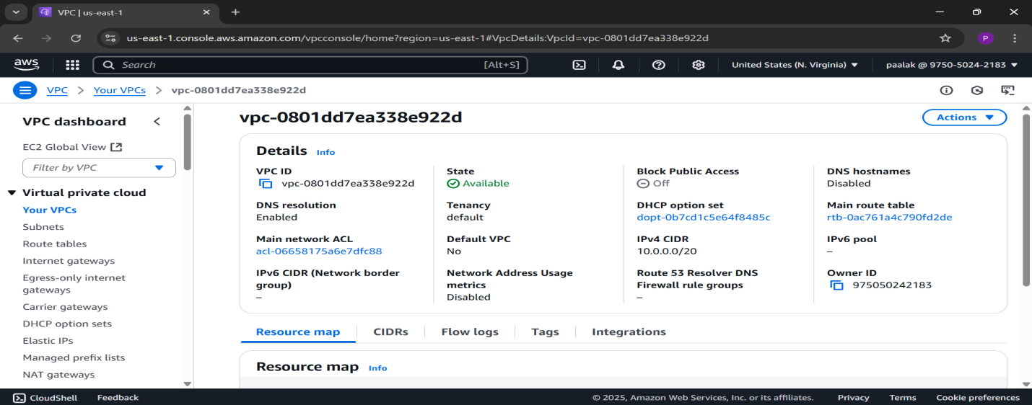

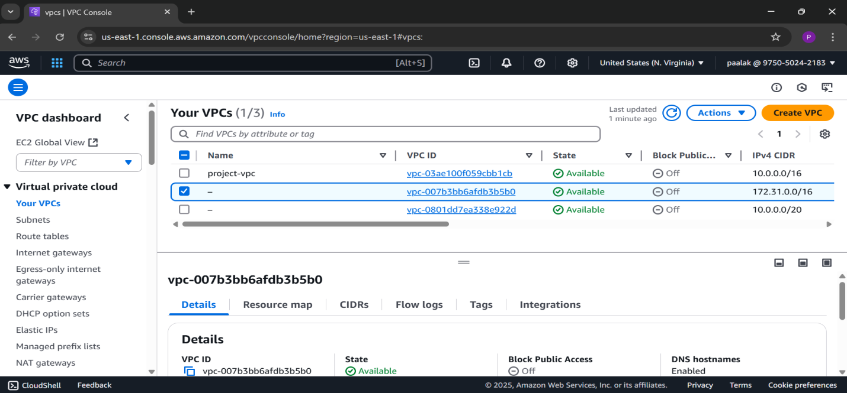

**Step 2. Create Subnets**

1. Go to **Subnets** → **Create Subnet**
2. **VPC**: Select your VPC
3. **Public Subnet**

* Subnet name: Public-Subnet
* AZ: eu-north -1a
* CIDR block: 10.0.1.0/24

1. **Private Subnet**

* Subnet name: Private-Subnet
* AZ: eu-north -1a
  + CIDR block: 10.0.2.0/24

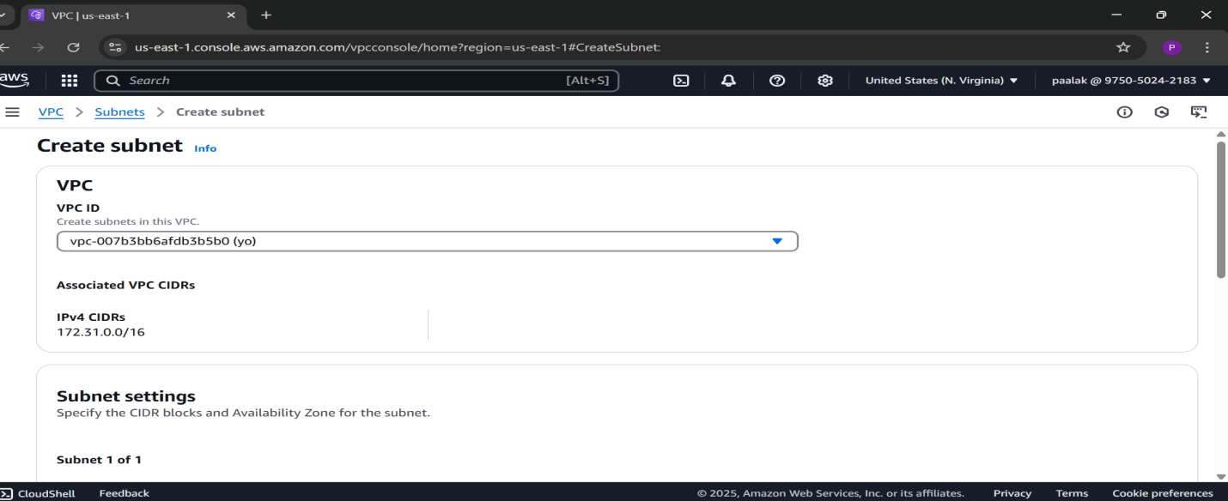

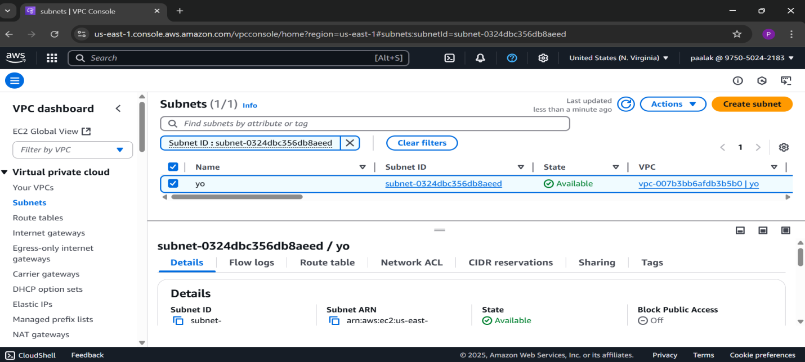

**Step 3. Create & Attach Internet Gateway**

1. Go to **Internet Gateways** → **Create IGW**
2. Name: My-IGW
3. After creating, go to **Actions** → **Attach to VPC** → Select your VPC

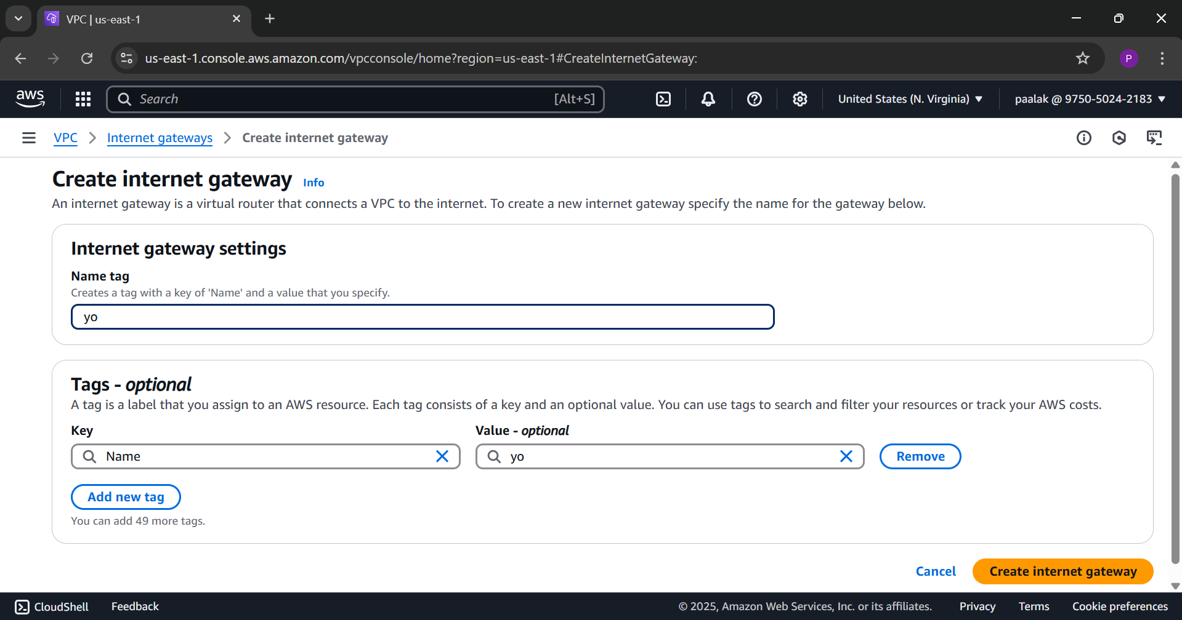

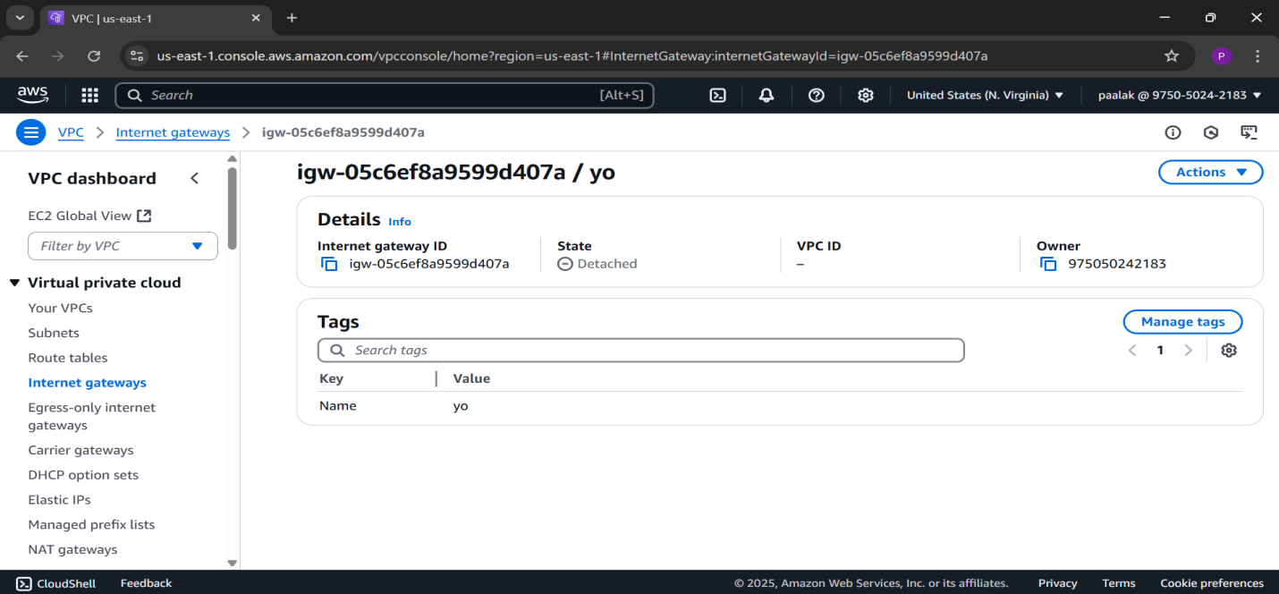

**Step 4. Create Route Tables**

1. Go to **Route Tables** → **Create Route Table**
   * Name: Public-RT
   * VPC: Project-VPC
2. Add route:  
   0.0.0.0/0 → Internet Gateway
3. Associate with Public-Subnet
4. Create **Private-RT**
5. Add route:0.0.0.0/0 → NAT Gateway
6. Associate with Private-Subnet

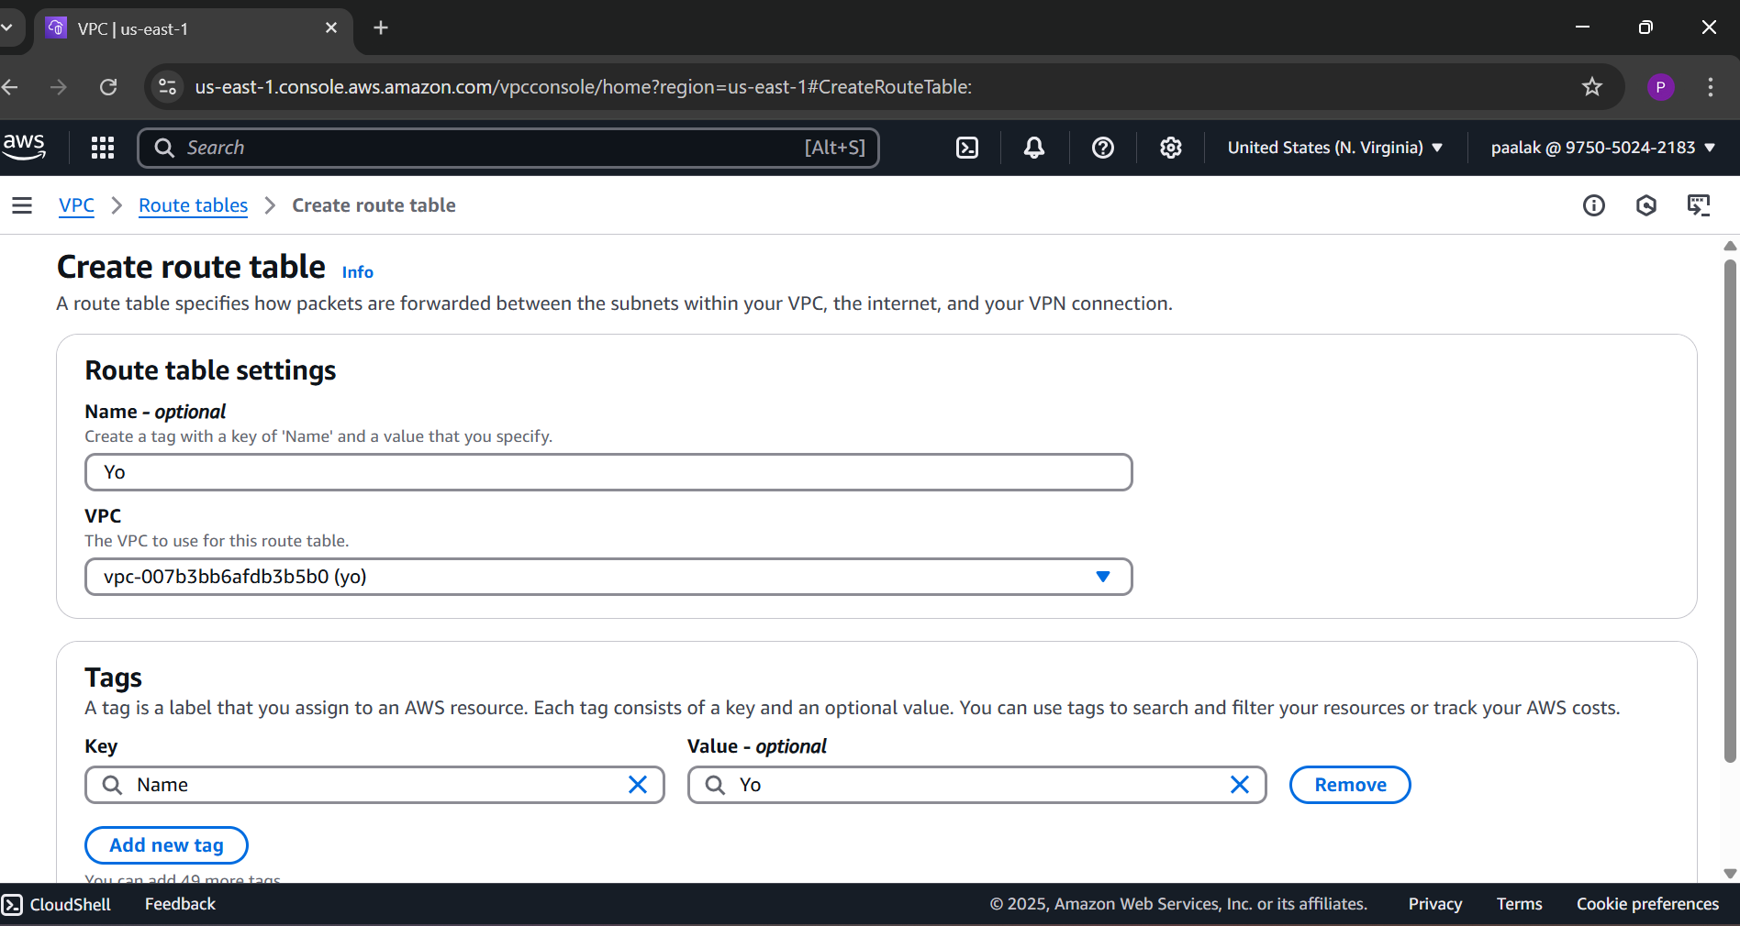

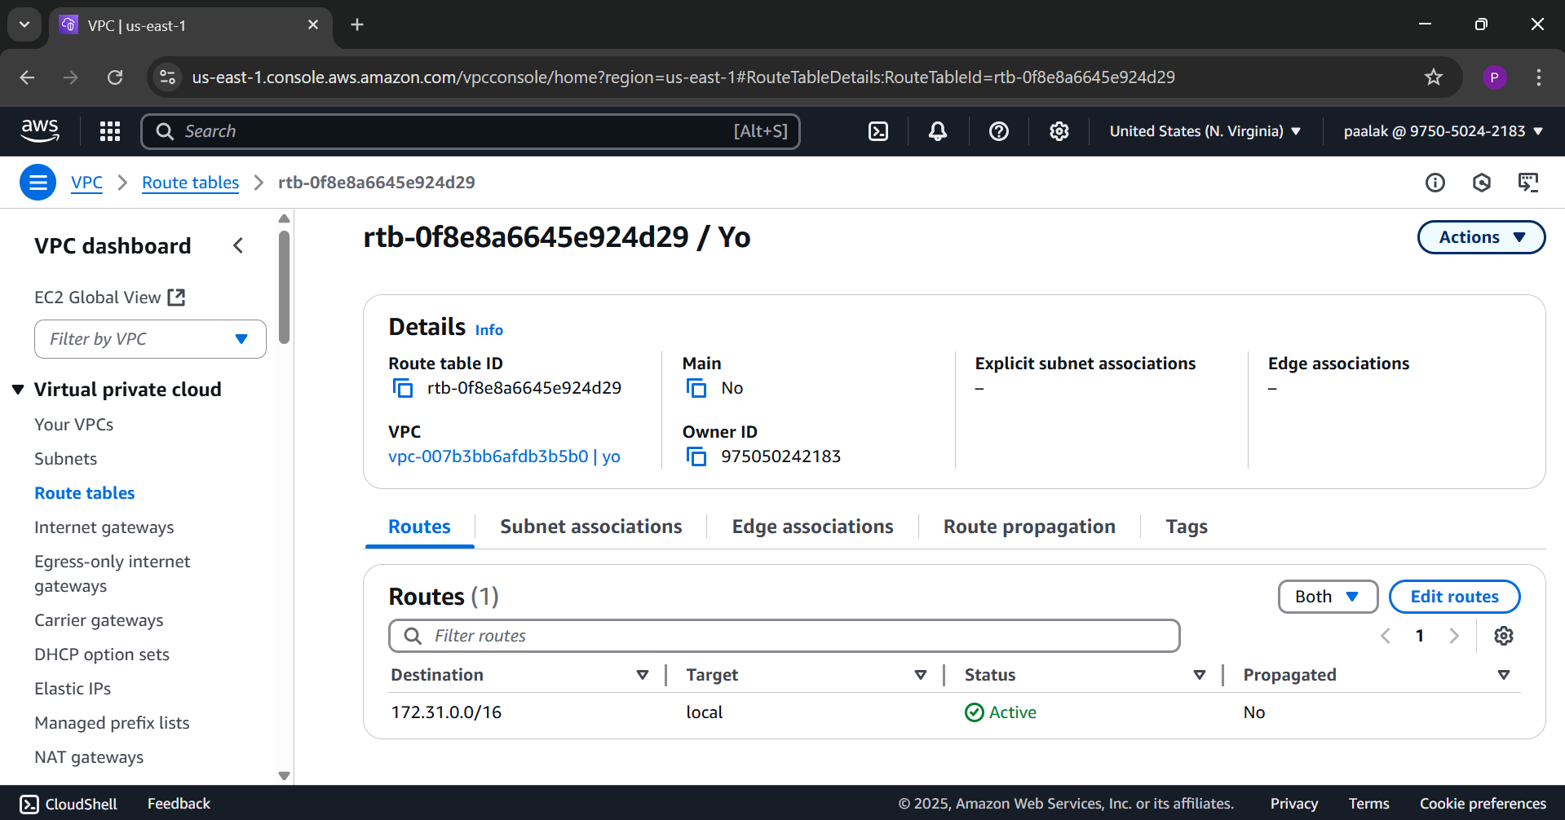

**Step 5: Create Security Groups**

1. **Bastion SG**
2. Name: Bastion-SG
3. Inbound:
   * Type: SSH, Port: 22, Source: your IP
4. Outbound: All traffic
5. **Backend SG**
6. Name: Backend-SG
   * Inbound:Type: SSH, Port: 22, Source: 10.0.1.0/24
7. Outbound: All traffic

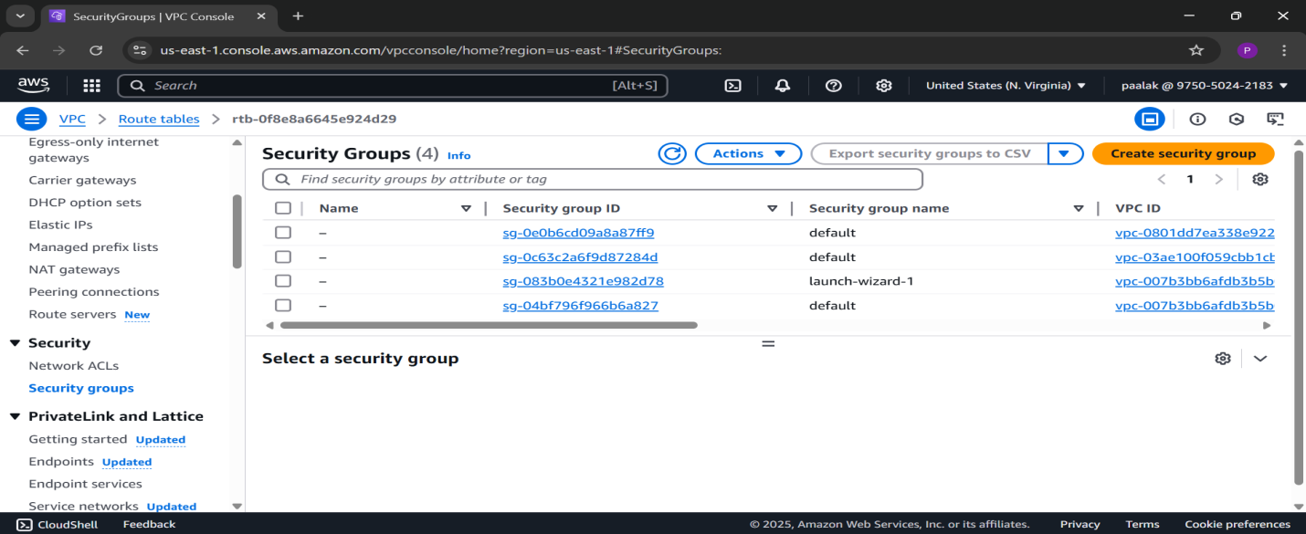

**Step 6: Launch EC2 Instances**

1. **Bastion Host**

* AMI: Ubuntu
* Subnet: Public-Subnet
* SG: Bastion-SG
* Key pair: use your .pem file
* Enable public IP

1. **Backend EC2**

* AMI: Ubuntu
* Subnet: Private-Subnet
* SG: Backend-SG
* Same key pair
* No public IP

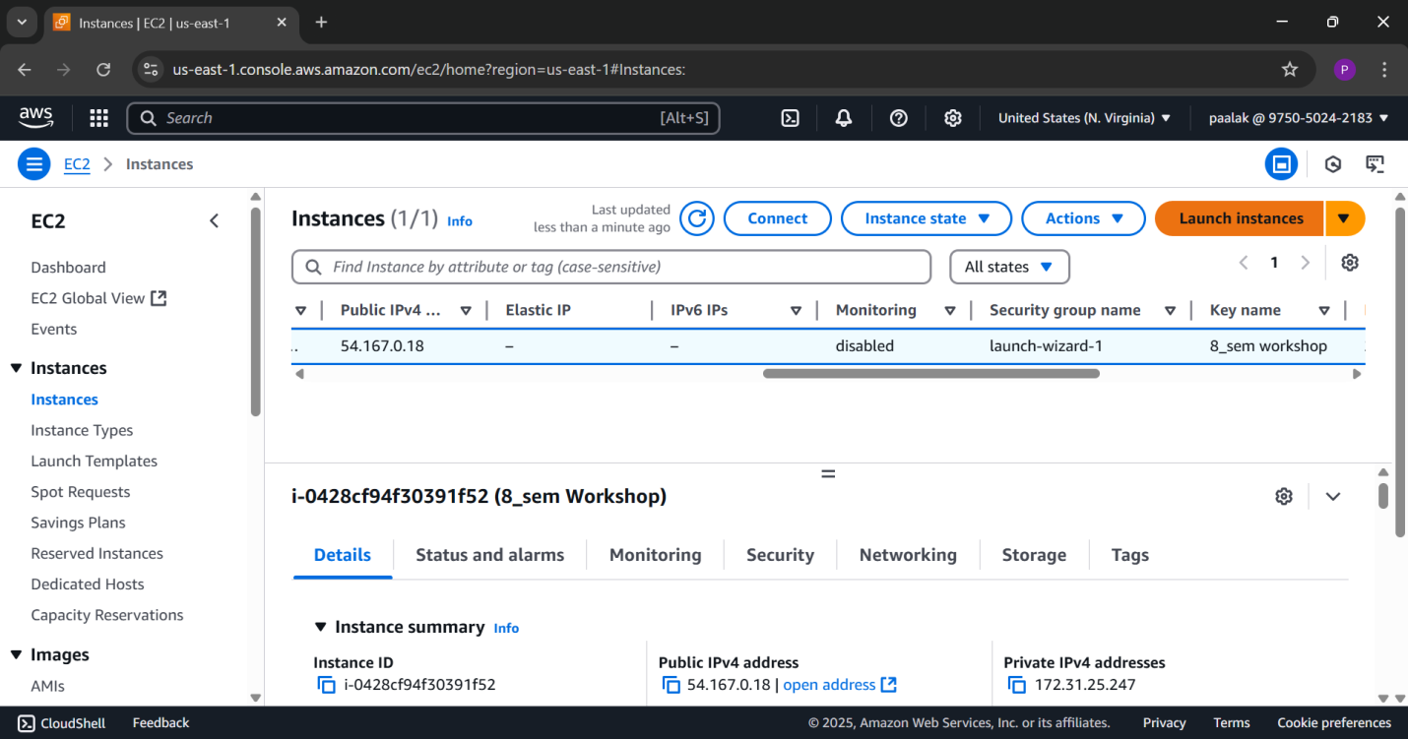

**Step 6:Test SSH access to Bastion Host** from your local machine using the Elastic IP:

1. ssh -i C:\Users\disha\Downloads\bostin-host.pem [ubuntu@13.51.60.153](mailto:ubuntu@13.51.60.153)

2. terraform/

├── main.tf

├── variables.tf

├── outputs.tf

└── terraform.tfvars

1. terraform init
2. terraform plan
3. terraform apply

